

BARTON STACEY PARISH COUNCIL

Ebay – Timber reflective keep off grass post – push in ground £7.80 for 12 inch or £9 for 18 inch
– plus £7.50 postage. So 20 posts would total £163.50 for 12 inch or £187.50 for 18 inch

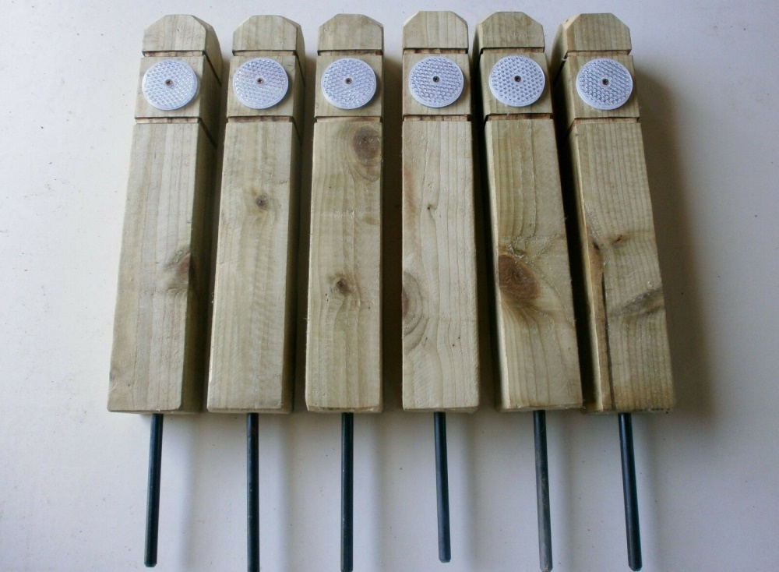

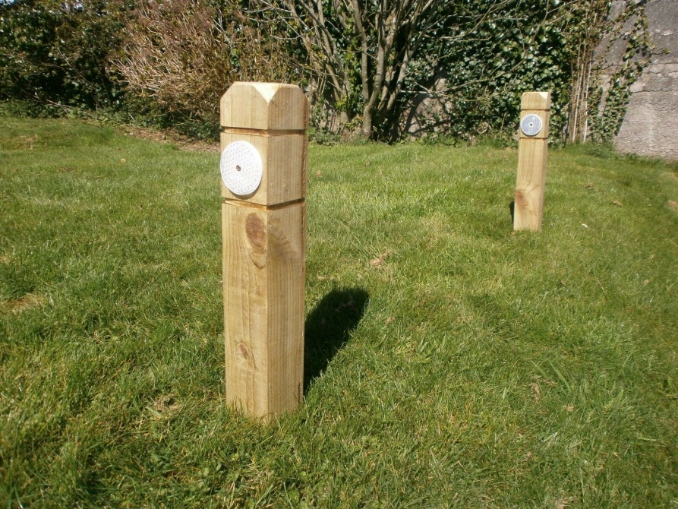

Post and chain ideas

Theworkplacedepot.co.uk - £47.17
Barriersdirect.co.uk - £68.15
Pittmantraffic.co.uk - £71.50
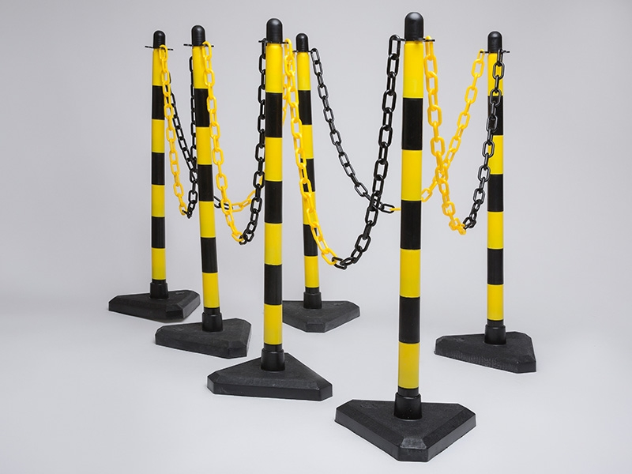



Chain 10m x 6mm (5 x 2m lengths)
Concrete filled bases
6 posts

